**PROJECT 1:**

Deploying a web server in Windows instance

Step 1: Create a Windows instance using AMI: Windows Server 2019 Base

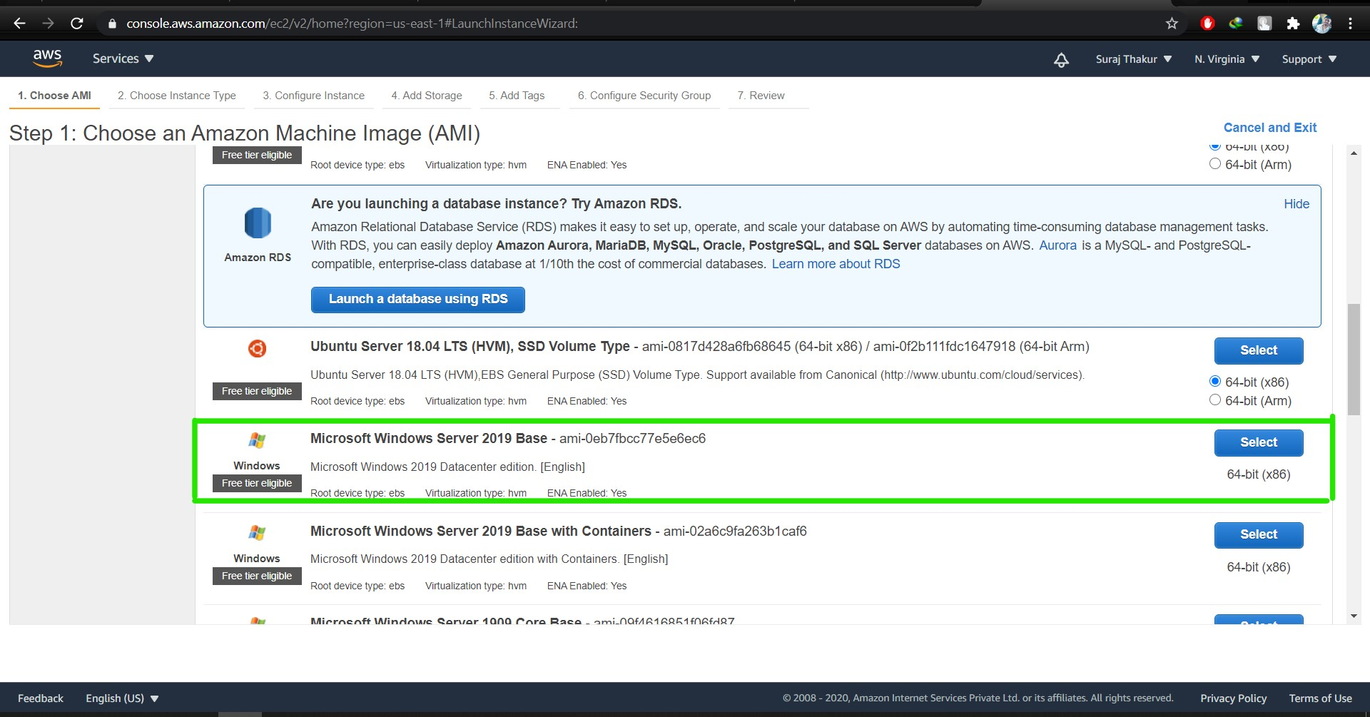

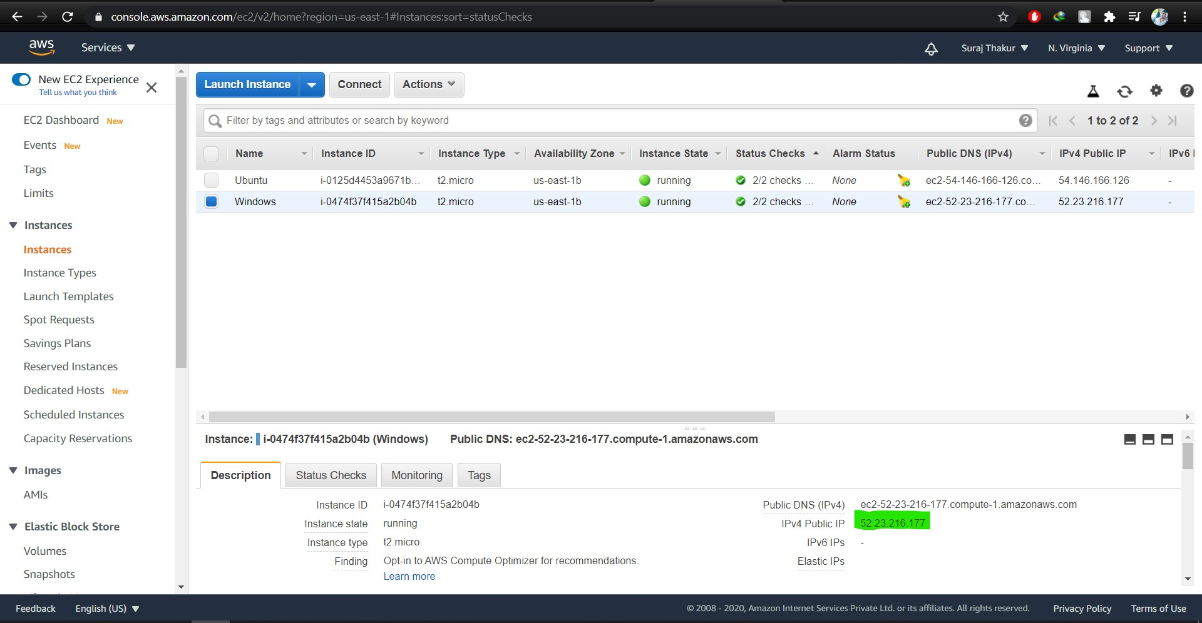

Step 2: Lauch the Windows instance using RDP.

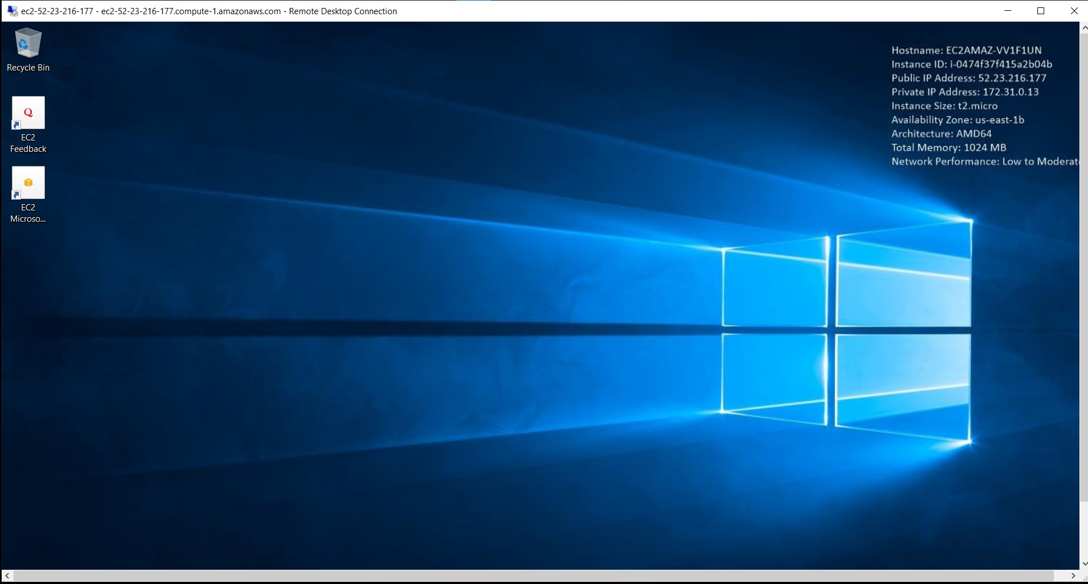

Step 3: Install IIS webserver using PowerShell ISE using command:

**Install-WindowsFeature -name Web-Server -IncludeManagementTools**

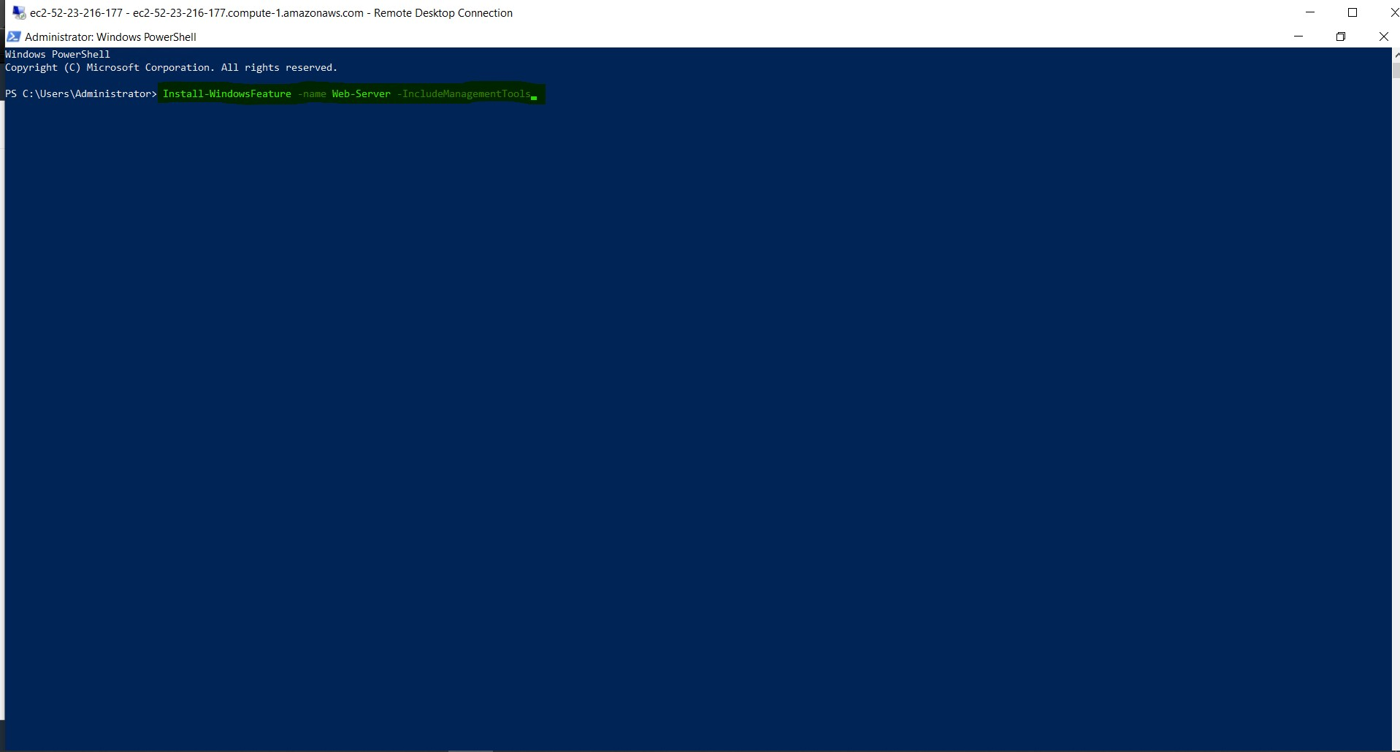

Step 4 : Verify successful installation of IIS webserver.

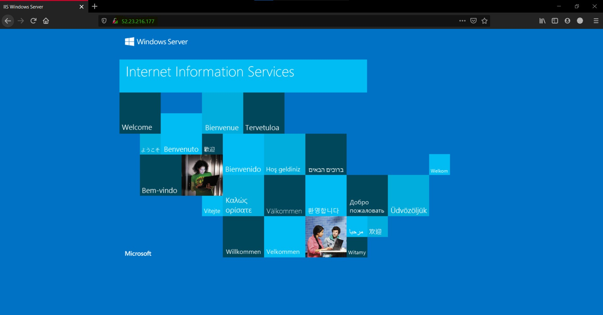

Q.1 What happens to the Public IP and Private Ip when an instance is restarted and stopped?

Ans:

When we reboot our machine, our public IP and private IP remain same.

When we stop and start our machine, private IP remains same whereas public IP changes.

Initial state private Ip and public IP:

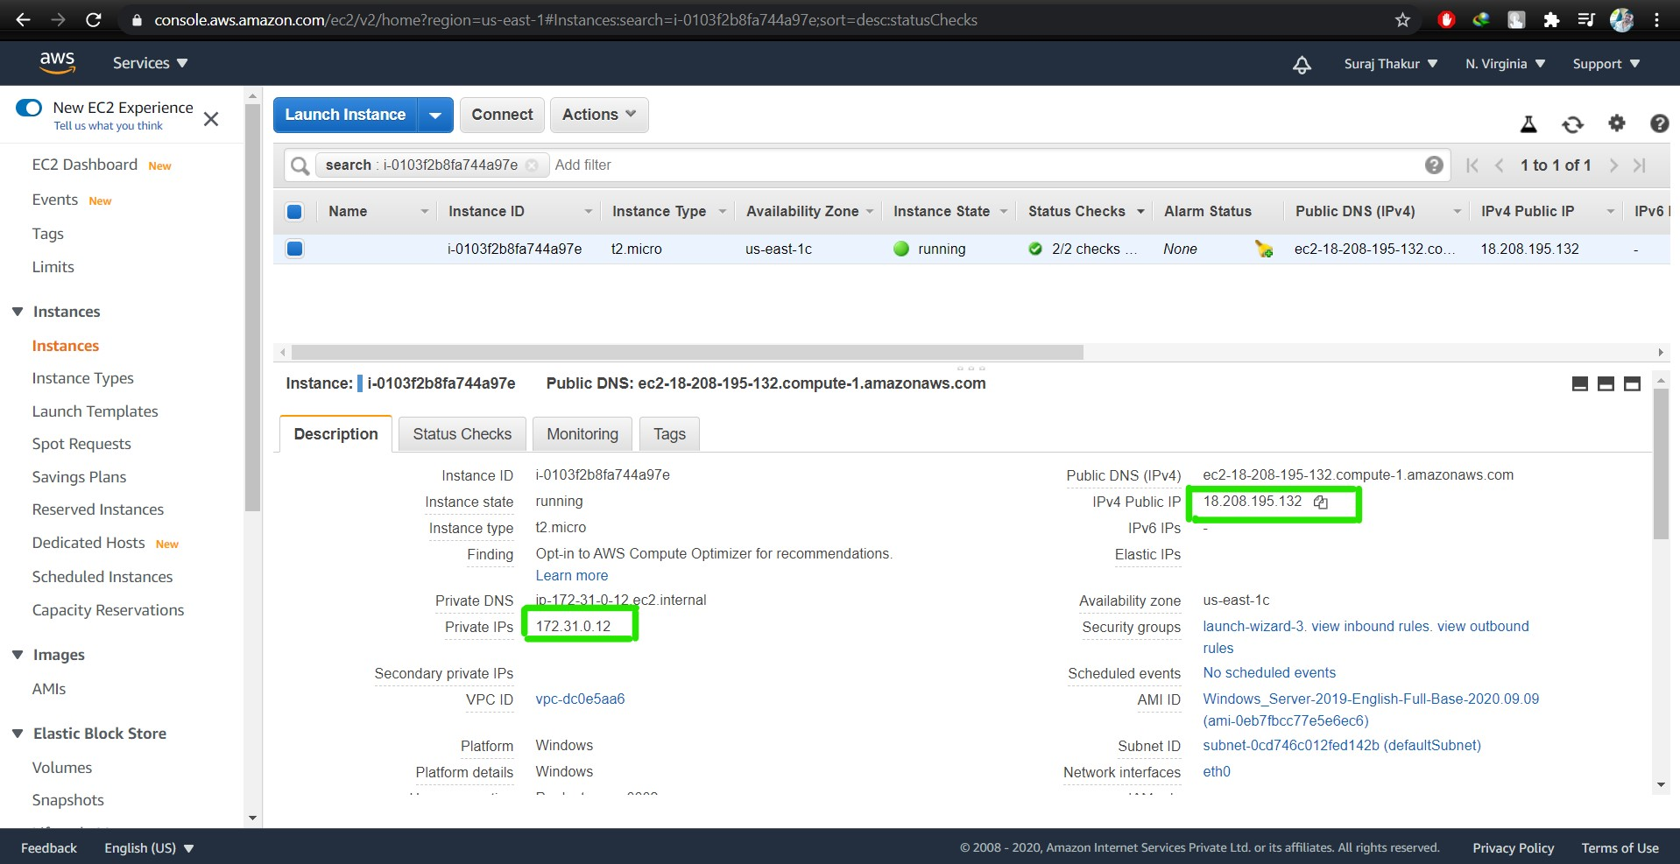

private IP and public IP after stopping and restarting machine:

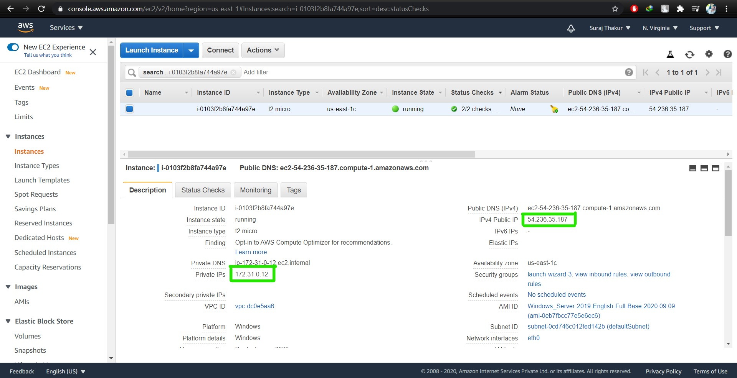

Q.2 What happens to the applications installed in the instance when we reboot, stop and terminate the it?

Ans: The applications installed in the instance will remain same as it is whether we reboot or stop the instance but everything goes down if we terminate the instance.